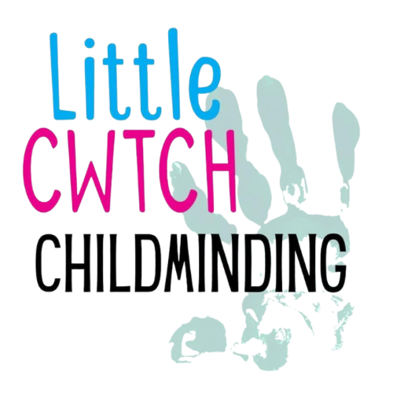
LittleCwtch Childminding

Rowan Kennedy-Brown and Billy Kennedy-Brown (both separately registered with CIW)

Quality of Care Review March 2026

Collecting Reviews
Questionnaires were distributed to all parents/guardians to gather feedback on the quality of care provided within the setting. These included a combination of rating-based questions and opportunities for written comments.
A total of 15 were handed out and 12 completed questionnaires were returned. This shows a strong level of engagement from parents and provides a reliable overview of satisfaction within the setting.

Summary of Responses
Overall, the feedback received from parents/guardians was extremely positive, with consistently high ratings across all areas of the service. Responses show that families feel their children are happy, well cared for, and supported in their development.

Well-being
All parents/guardians agreed that the setting supports their child’s well-being effectively. In the first two questions the below graphs show the responses.
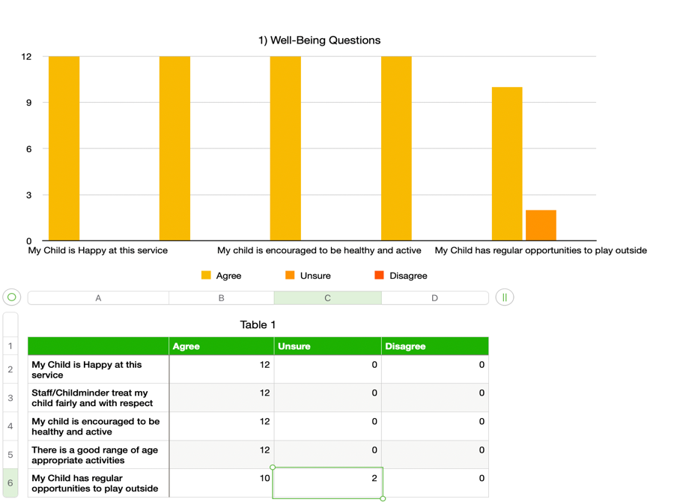
This reflects that children feel safe, secure, and happy within the setting and have a strong sense of belonging. There was also a comment box available, several people commented. Two of the comments was directed at the outdoor use, acknowledging the challenging winter again with storms and constant rain of 2026 as to why the outdoor space has not been utilized as much

The second question asked the parent/guardian what they would rate LittleCwtch Childminding overall for well-being. 12 out of 12 returned answered excellent to this question. Below shows the year by year.
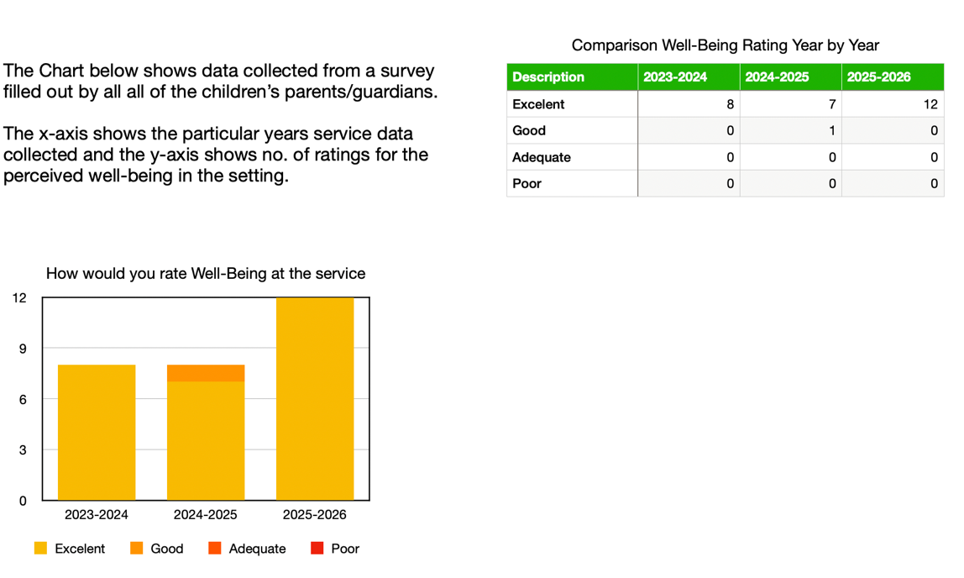

Care and Development
Questions 3 was a group of care and development questions. This looked at whether the care is good, right support is given, feedback given about their child and that the child knows who to go to meet the child’s needs. Overall the feedback was that the parent/guardian is always happy with the care and development their child is getting. There was also a comment box available, several people commented again. One comment was stating that their child was always happy when attending the setting.
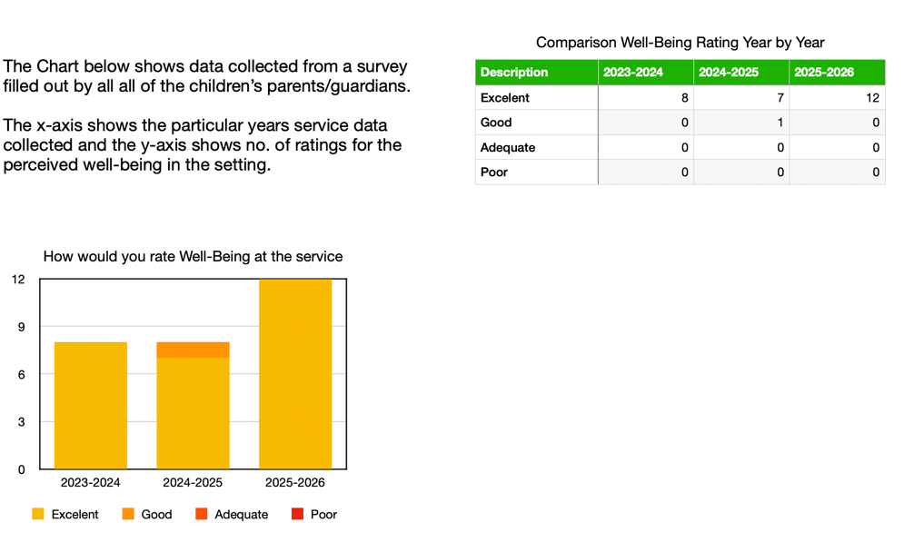

The fourth questions asked the parent/guardian to rate the overall care and development in our setting. 11 out of 12 gave excellent as the answer, 1 out of 12 answered good.
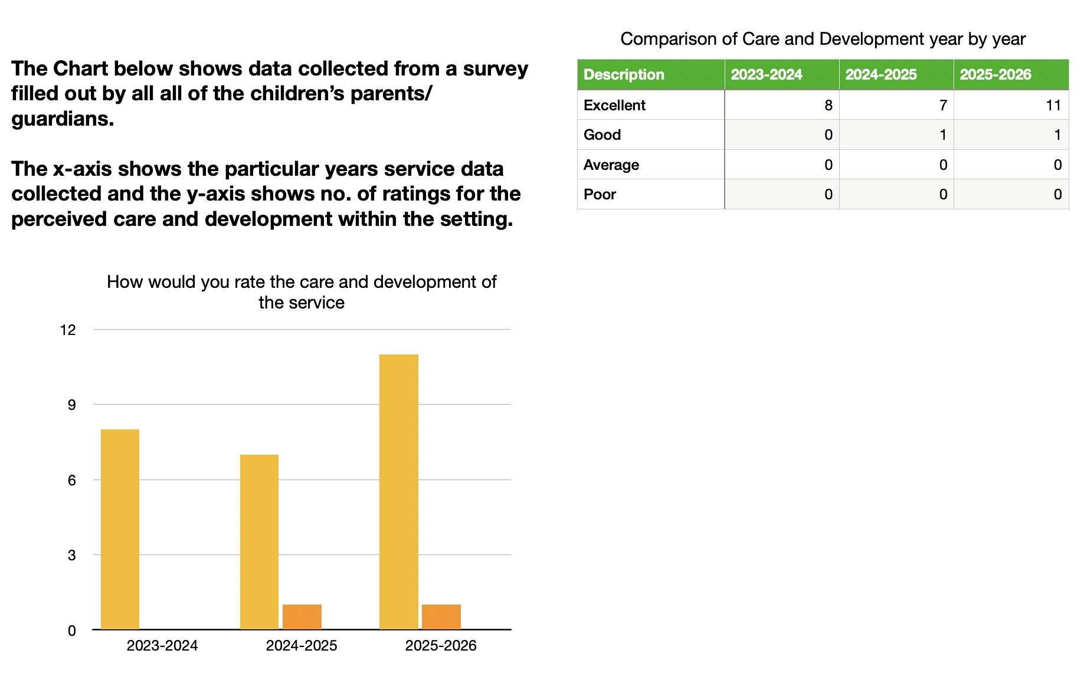

Environment
The fifth question was created to ask about the environment of the setting. Everyone is very happy with the cleanliness, safe and security, good quality toys and learning material. There was also a comment box available, no one commented. Please find evidence below: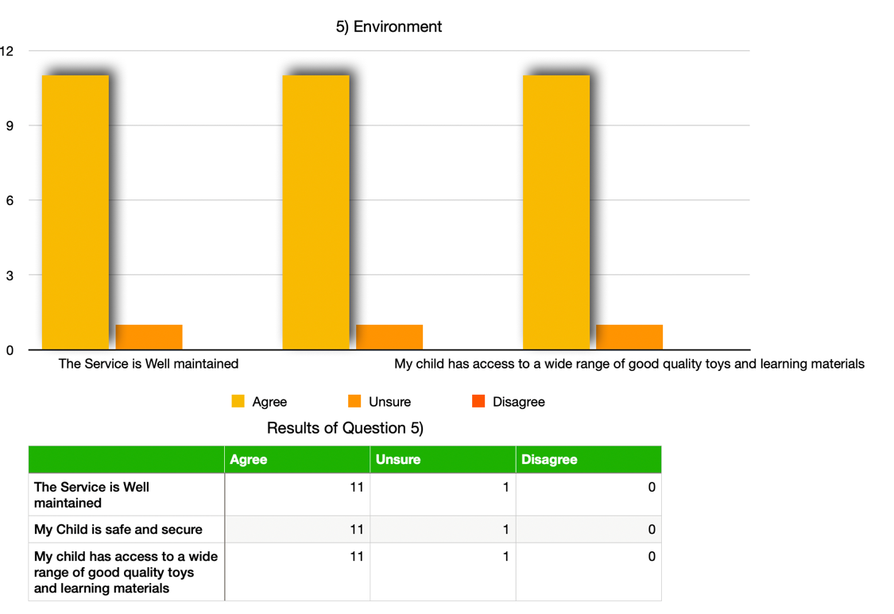

Question 6 asked parent/guardians to rate the environment as an overall. 11 out of 12 parents gave excellent as an overall rating 1 giving good. Feedback suggests the environment continues to be welcoming, well-maintained, and supportive of children’s play and development.

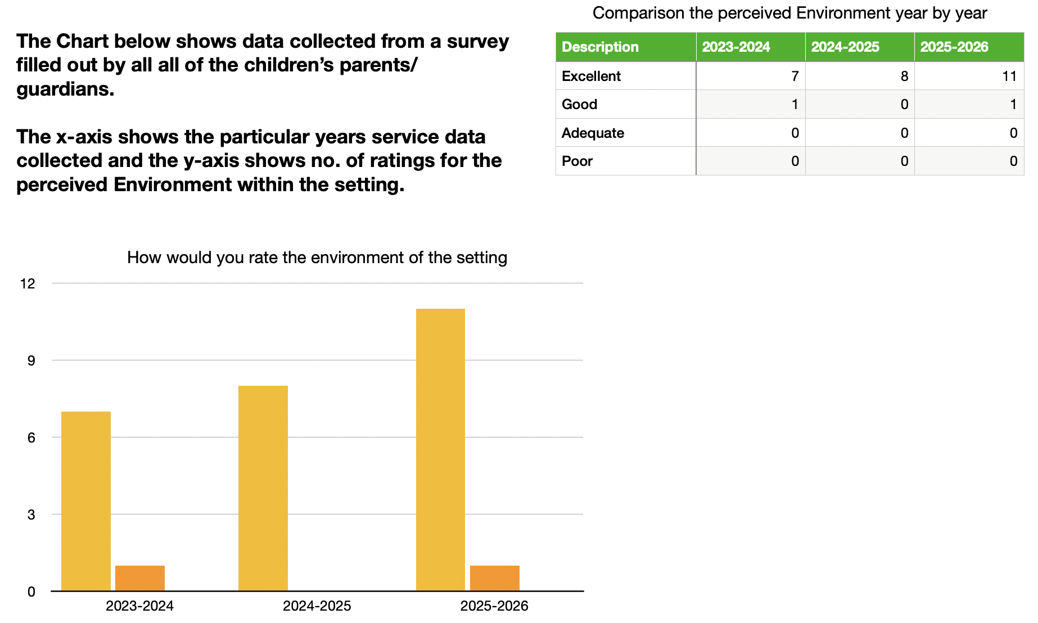

Leadership and Management
Question 7 asked the parent/guardian about leadership and management of the childcare setting. This included approaching staff, understand complaints procedure and the opportunity to give feedback. There was also a comment box available, one person commented “very well organised and ran”
. 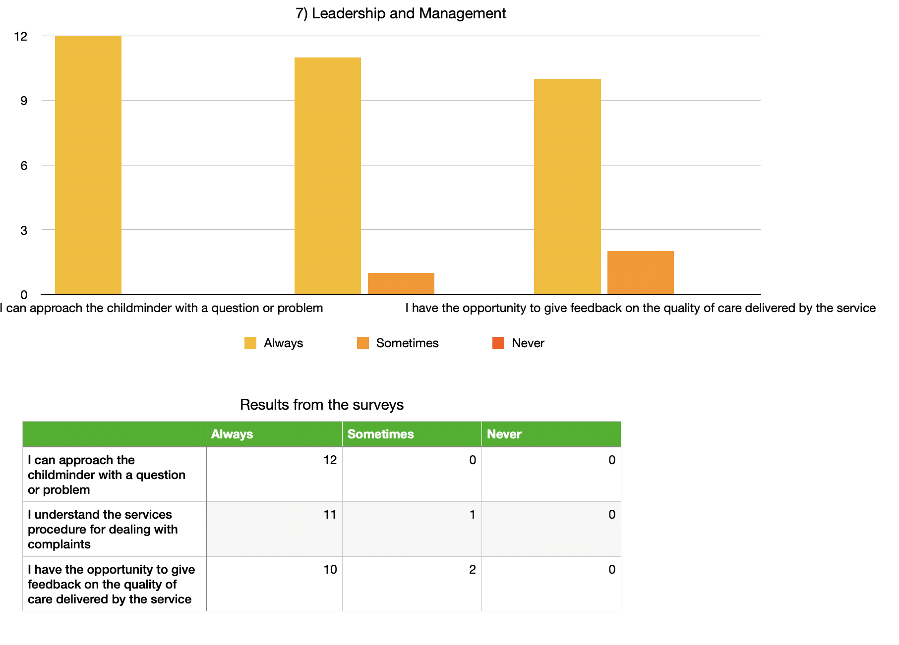
This highlights strong confidence in how the setting is run and the relationships built with families.
Question 8 asked the parents\guardians to give an overall rating for the leadership and management for the setting. 11 out of 12 stated excellent and 1 out of 12 stated good.
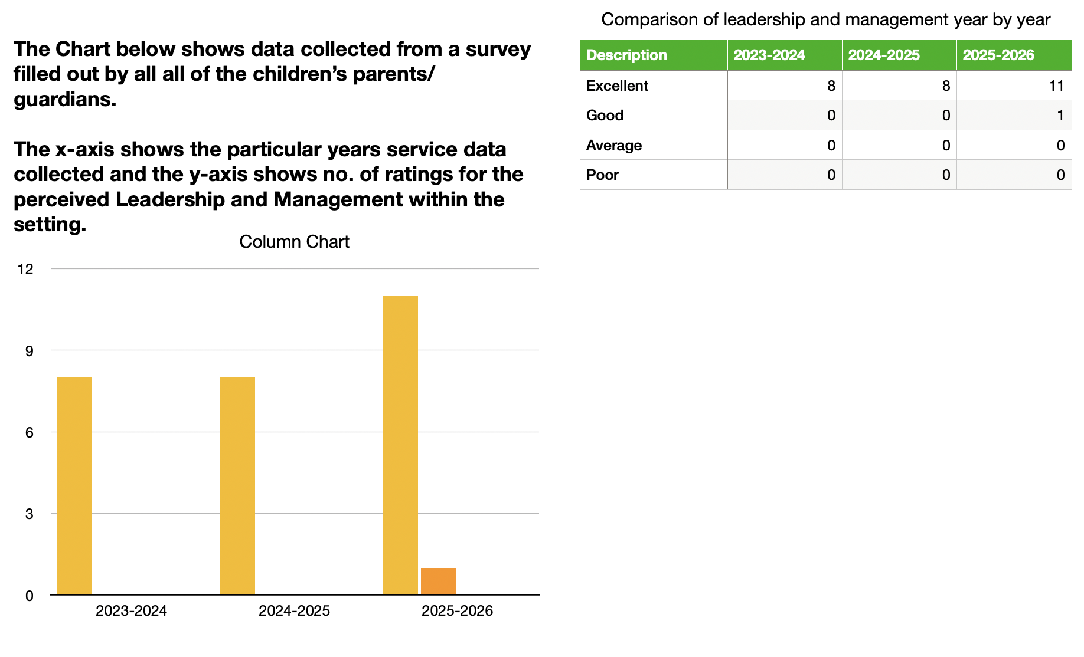

Welsh Language – Active Offer
Questions 9 asked about the use of active offer for Welsh language. In an change from last years report, 7 out of 12 stated they were aware of and understood the Welsh Language offer. 1 answered sometimes and 4 answered “Unsure” writing it as an added option.

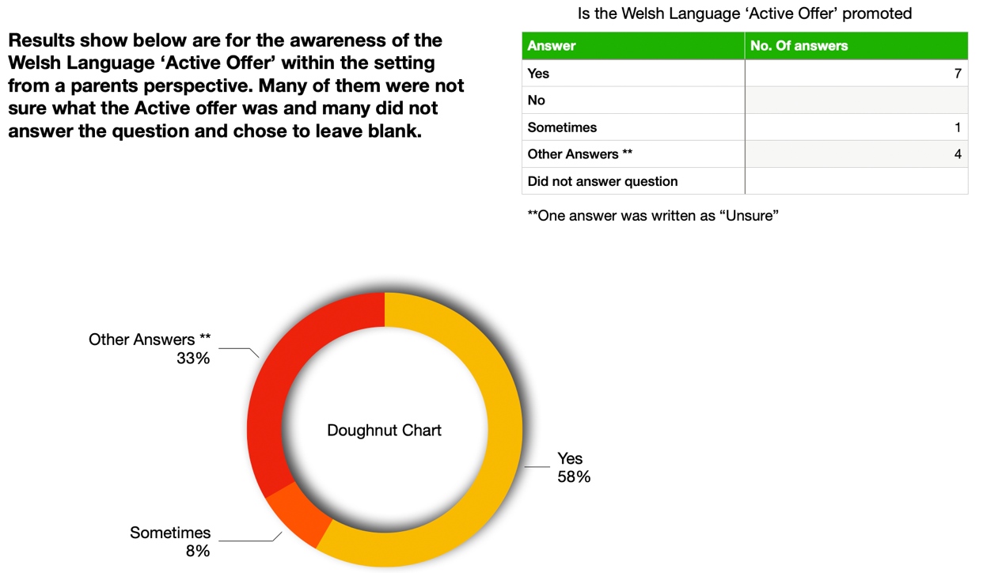
Responses showed a slightly more mixed understanding of the Welsh language provision:
- 7 Yes
- 1 Sometimes
- 4 Unsure
While the majority are aware of the Welsh language being promoted, there was some verbal confirmation that they were unsure of what the offer meant, often citing being new parents and never coming across the term but understood we use Welsh language as often as possible and where appropriate.

Parent/Guardian Comments
Written feedback from parents/guardians was very positive and highlighted the caring nature of the setting, strong communication, and children’s happiness.
Some comments included:
“Have very recently started a few months ago but very happy with the service as a whole. Seems to be a very caring place to be!”
“We are very happy with the service. Very caring and warm environment.”
“I am satisfied with the level of care provided and Billy and Rowan communicate well with me. They care about my child's well-being and will let me know about their observations so we can work together.”
“My child is very settled and happy. It is obvious they are happy when in the setting and they look forward to going each time.”
These comments reflect strong relationships with families and a positive, home-like environment for children.

Overall Summary
The 2026 questionnaire results show a consistently high level of satisfaction across all areas of the service. The majority of responses were rated as Excellent, with the remaining responses rated as Good, and no negative feedback recorded.
Key strengths identified:
- Strong focus on children’s happiness and well-being
- High-quality care and development support
- A safe, welcoming, and engaging environment
- Positive relationships and communication with families
Area for development:
- Continue to increase the awareness and visibility of the Welsh Language Active Offer

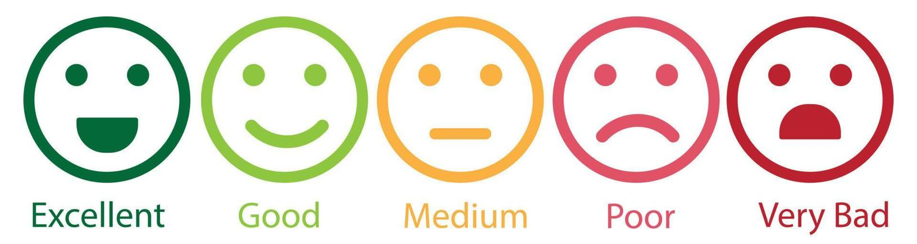

Please find below a summary of the responses below:

- Enjoyment = 2/2 answered excellent
- Fun = 2/2 answered excellent
- Like the activity, toys and resources = 2/2 answered excellent
- Do you like the food provided = 2/2 answered Excellent
- Looking forward to LittleCwtch Childminding = 2/2 answered excellent
- Open question about what are the things that you learn at the setting. Answers included Lights and sounds and singing time and outside play when it the weather is not raining
Overall the outcome was very positive and we were so happy that some children were able to answer the thoughts and feelings towards our quality of care report.

Actions for Improvement
Following the 2026 questionnaire feedback, the overall responses remain extremely positive, with the majority of areas rated as Excellent. While no major concerns were raised, the following actions have been identified to further strengthen and develop the service.
Welsh Language – Active Offer
We will continue to build on the use of Welsh within the setting by making it more visible to parents. This will include sharing examples of Welsh words, songs, and phrases used in daily routines, as well as highlighting activities through updates and displays. I will be making weekly word targets to improve and increase my use of welsh on a day to day basis.
Maintaining High Standards
We will continue to reflect on our daily practice to ensure consistency across all areas of care, development, environment, and leadership. Informal feedback from parents will continue to be welcomed to support ongoing improvements. I will ensure that my training is up to date and I am actively looking at new training that can be completed to further my knowledge.
Parent Communication and Partnership
We will maintain and further develop strong relationships with families by continuing to provide regular updates about children’s experiences and development. Opportunities for ongoing feedback will remain available outside of the annual questionnaire. Parent/guardian communication will continue to be open and honest.
Continuous Improvement
We will continue to review and develop the provision through self-evaluation, training, and adapting our practice to meet the needs of the children attending the setting. This will be reflected as we adapt to opening our setting to more children under 18 months as the 4 year olds move onto a school setting.
Overall Aim
To maintain the high standard of care already recognised by parents, while continuing to make small improvements that enhance the experience for all children and families.

Self-Evaluation

Overall, I am happy with the parents responses and feedback given to aid in establishing areas of strength and areas that can be improved. I am proud of the setting we continue to be and are excited to welcome new little ones into our setting as the older children venture to full time primary school. I will continue to communicate with parents with an open and honest approach as well as listening to any concerns that parents/guardians may have. I will work closely with families to ensure that the quality of care is high and that we are providing personal care that meets each individuals personal needs.
Since the previous review, we have continued to develop our use of the Welsh language within the setting. While there has been a noticeable improvement in awareness compared to last year, this year’s responses show that some parents are still unsure about what the ‘Active Offer’ means. This has highlighted the need for us to continue making this more visible and clearly communicated to families, which we will build on going forward. I plan to promote the welsh language use in our setting through social media posts as well as feedback and milestone writeups on the procare app (which parents can access).
The feedback suggests that there are no major changes required to the quality of care currently being provided. Parents have expressed high levels of satisfaction across all areas, including well-being, care and development, the environment, and leadership and management. I continue to maintain strong, positive relationships with families, ensuring I am approachable, professional, and responsive to both children’s and parents’ needs.
All required training, including DBS, safeguarding, and first aid, remains up to date. I will continue to reflect on practice, maintain high standards, and make small improvements where needed to ensure the setting continues to provide a safe, caring, and supportive environment for all children. I look forward to another busy and successful year in childminding alongside my other business partner.

