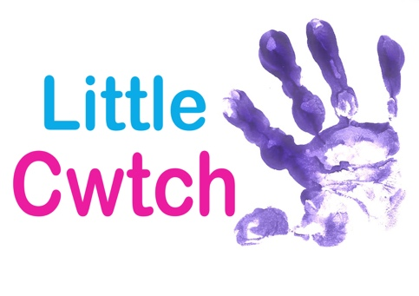
ENVIROMENTAL POLICY

Objectives

- To maintain a healthy and safe working environment for all staff, tutors and volunteers.

- To minimize any negative impact of Little Cwtch’s operations

Policy

- Evaluate the environmental impact of all purchases and prioritize low impact and energy efficient products.

- Prioritize the use of public transport and encourage car-sharing amongst the company

- Prioritize use of technology to minimize the environmental impact of day to day administration and communication

- Conduct an annual environmental review of the company’s operation to identify weaknesses and possible improvements

- Co-operate positively with local and regional environmental initiatives

Responsibilities

All members of the company and contracted staff will be given a copy of the company’s environmental policy and have collective responsibilities for the proper implementation of the policy.

Billy Kennedy-Brown has primary responsibility for the policy development, implementation and monitoring.

Version Control
Revised November 2019

