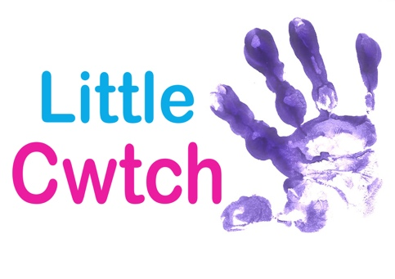
HEALTH AND SAFETY POLICY

Little Cwtch is committed to protecting the health and safety of its staff, participants, parents/guardians and all others whom our work brings us into contact. The company’s policy is to provide and maintain safe and healthy working conditions, equipment and systems of work, for all those working for the company, and to provide staff with such information, training and supervision as they need for this purpose.

The company recognizes its responsibilities under the Health and Safety at Work Act and other related legislation and seeks to satisfy its obligations by adoption of this Health and Safety Policy.

The Policy will be reviewed annually or more frequency if work practices change.

The final overall responsibility for the safety and well-being of the staff, participants and parents and guardian’s rests with management but the day to day management of the policy has been delegated below.

Rowan Kennedy-Brown is appointed member with primary responsibility of the day to day implementation of the policy.

All staff and tutors are made aware of their own responsibilities. The company believes that co-operation and consultation with all tutors and freelancers is essential to maintaining a holistic approach to the policy.

The policy determines who has specific responsibilities for each area of concern and this is reflected in the job descriptions in the company.

A copy of the policy is given to each member of the company and further copies are available from Rowan Kennedy-Brown.

Version Control
Revised November 2019

