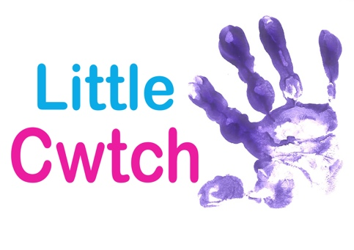
HEALTH AND SAFETY POLICY

Divisions of Responsibilities

Management

- To research, revise and generate the Health and Safety Policy.

- Production and distribution of the policy to all staff, tutors and clients.

- To answer questions from staff and clients about the policy and related matters

- To oversee the implementation of Health and Safety policy issues

- To provide induction to new tutors and staff in Health and Safety matters.

- To ensure that a proper risk assessment is carried out for all activities.

- To provide first aid kits and accident/incident books

All Staff

- To take reasonable care for the health and safety of him/herself and others who may be affected by his or her acts or omissions

- To use protective equipment provided and follow safety instructions given, where appropriate.

- To co-operate with other tutors and staff in the operation of the Health and Safety policy.

- Not to interfere with or misuse anything provided in the interests of Health and Safety

- To report any danger, defect, accident or near miss to management

- To follow procedures for fire, first aid, security and use of equipment.

OUTREACH AND PARTICIPATION ACTIVITY

Little Cwtch undertakes workshops and classes in third party spaces and locations and all staff engaged in these projects are requested to ensure that they adhere to any Health and Safety policies in place at the location.
The client booking Little Cwtch is responsible for providing copies of any policies in force prior to the workshop/classes taking place.

Version Control
Revised November 2019

