LittleCwtch Childminding

Rowan Kennedy-Brown and Billy Kennedy-Brown (both separately registered with CIW)

Quality of Care Review March 2024

Collecting reviews:

I handed out paper questionnaires in order to gather information from the parent/guardian as well as the children that are older that 2 years or age. The parent/guardians were notified about the questionnaire in their child’s bag as well as reminded to bring back the questionnaire by the specific date.
The questionnaire included multiple choice answers as well as open comment answers. I also wanted to gather information from the children themselves so created a questionnaire that included smiley faces for them to circle or colour in with the aid of an adult at home. I received 8 questionnaires back with 3 not being brought back.

Numbers:
At the time of handing out the questionnaire I received 9 finished questionnaires. I handed out 11 questionnaires.

Summery of responses:
The feedback and comments from the questionnaire where very positive overall. The first group of questions was regarding the well being of the child. Please find below the response in a bar chart and response box.

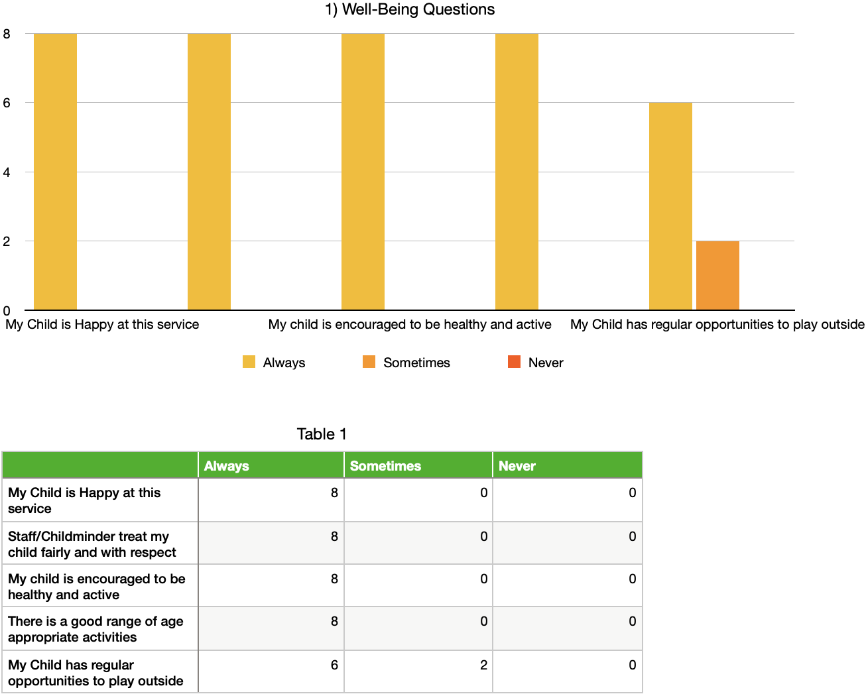

This is very good response to the overall feedback from the parent/guardian that they are very satisfied with the welfare of their child in our setting. There was also a comment box available, no one commented.
The second question asked the parent/guardian what they would rate LittleCwtch Childminding overall for well-being. 100% answered excellent to this question.

Questions 3 was a group of care and development questions. This looked at whether the care is good, right support is given, feedback given about their child and that the child knows who to go to meet the child’s needs. Overall the feedback was that the parent/guardian is always happy with the care and development their child is getting. There was also a comment box available, no one commented.

Please find below a summary of our responses:
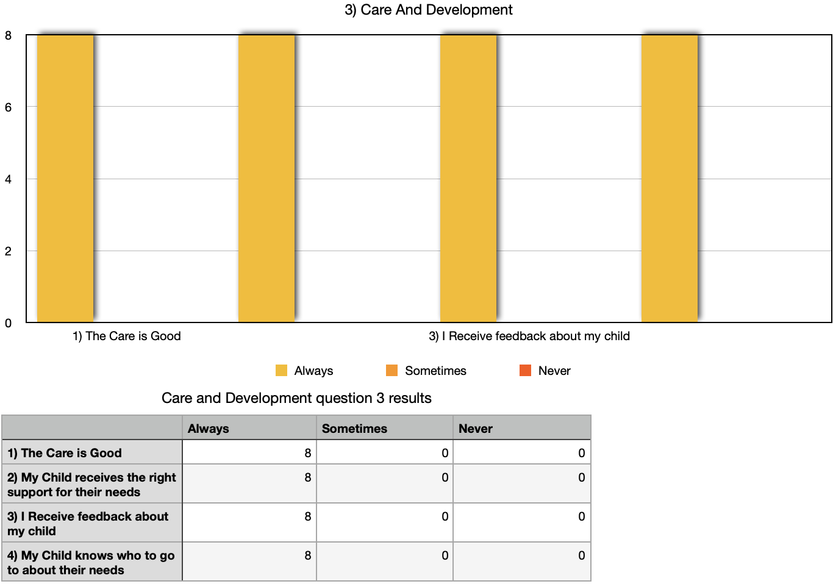

The fourth questions asked the parent/guardian to rate the overall care and development in our setting. 100% gave excellent as the answer.

The fifth question was created to ask about the environment of the setting. Everyone is very happy with the cleanliness, safe and security, good quality toys and learning material. There was also a comment box available, no one commented. Please find evidence below:

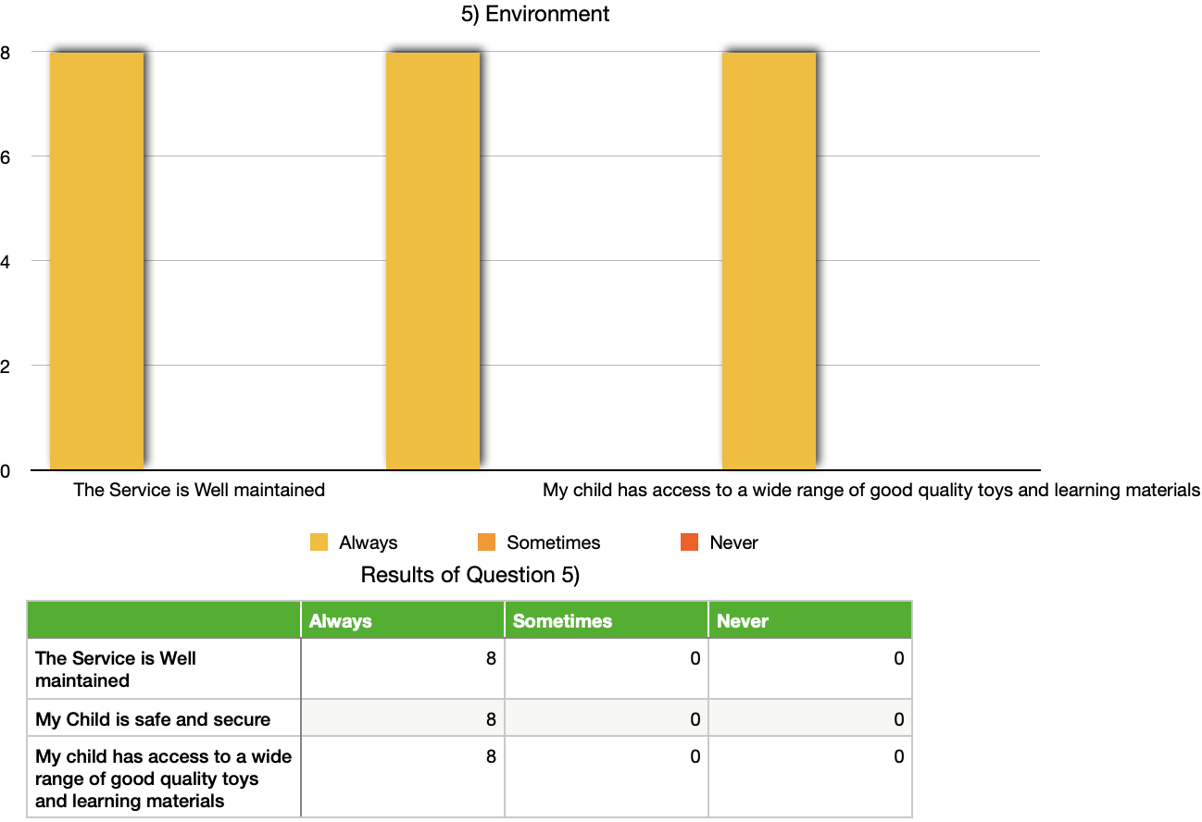

Question 6 asked parent/guardians to rate the environment as an overall. 7/8 said excellent and 1/8 stated that they gave it an good overall rating.

Question 7 asked the parent/guardian about leadership and management of the childcare setting. This included approaching staff, understand complaints procedure and the opportunity to give feedback. There was also a comment box available, no one commented.

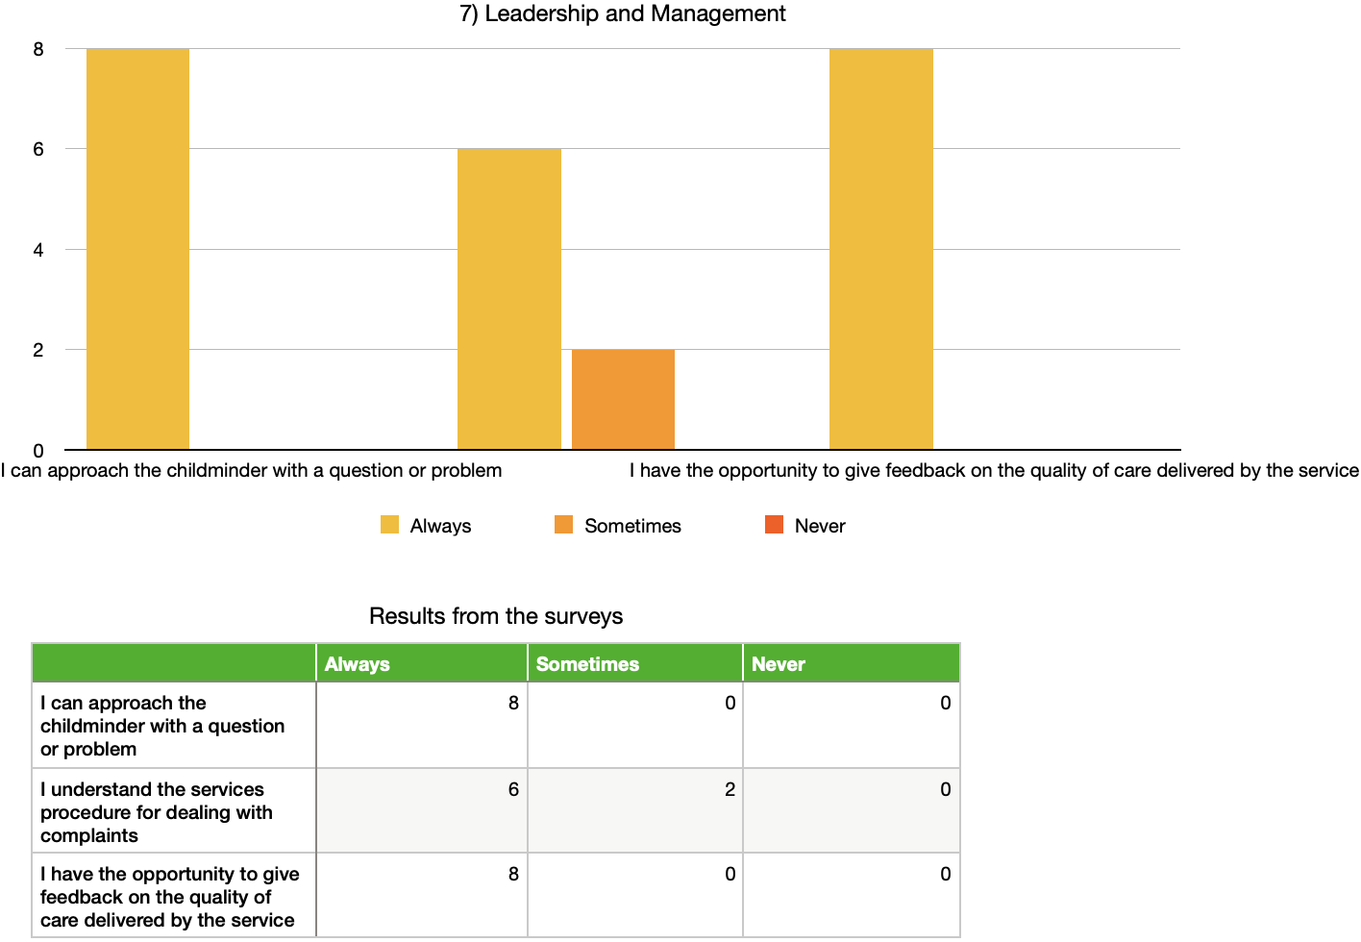

From this I will be looking into how to let parents know how to make a complaint and what the procedure is with this. We do have this information available on our website which is available to the public as well as the parents/guardians.

Question 8 asked the parents\guardians to give an overall rating for the leadership and management for the setting. 8/8 stated excellent.

Questions 9 asked about the use of active offer for welsh language. From the amount of unknown and answers not given to this question I can see that this was not worded and made clear. I will look at this for next time.

Question 10 asked the parent/guardian to give a comment/feedback in their own words regarding the setting. All comments were very positive and here are some below:

“I am very satisfied with the level of care provided. My child always has a good time and is happy to go there. No problems from me”

“ We are extremely satisfied with the care that is given. Our daughter is engaged, loved ande well looked after. This is never a day where she doesn’t want to attend care and is always happy and excited to tell us about her fun day”

“I am very satisfied. He goes into the setting happy and comes home happy. He is excited to see his friends as well as Billy and Rowan. Hes also excited when he sees them anywhere else which suggests he likes them very much.”

“Very satisfied. C loved going, he’s learning lots of different skills and having great fun also.”

“very satisfied. Always kept up to date and informed. My child seems to be benefitting a lot from socializing and the setting has improved her development. Very friendly and supportive setting.”
“We are very satisfied with the level of care provided for our child, our child has gained confidence, language skills, social skills and has the opportunity to grow and develop even more in their care. A special effort is made to cater for our child’s eating habits, it is very much appreciated.”

There were 5 responses given back to us by the older children with their own questionnaire. We used a smiley face questionnaire for the children. please find below an example of the smiley faces printed on the questionnaire

Please find below a summary of the responses below:

- Enjoyment = 4/5 answered excellent, 1/5 answered good.
- Fun = 5/5 answered excellent
- Like the activity, toys and resources = 4/5 answered excellent, 1/5 answered good
- Do you like the food provided = 1/5 n/a as they provide the food for their child. 1/5 didn’t answer this question, 1/5 answered excellent, 2/5 answered good.
- Looking forward to LittleCwtch Childminding = 5/5 answered excellent
- Open question about what are the things that you learn at the setting. Answers included numbers, colours, animals, songs, playing nicely with A, peek a boo, clapping, colours,

Overall the outcome was very positive and we were so happy that some children were able to answer the thoughts and feelings towards our quality of care report.

Summary and self evaluation:

Overall I am very happy with the responses and comments made by the parents/guardians for the children who attend our setting. Everyone was very positive and the feedback was very good. From the comments and the not understanding regarding Welsh in our setting I will take this feedback that we need to inform parents more about the Welsh language offered to their child during their time in our setting. This is something we will both work on going forward. I will also share the website address with parents so they are able to familiarise themselves with our policies and complaints procedure.

From the feedback given I feel like there are no major changes that need to be made to the quality of care we are providing for the children. All parents are happy and positive about many aspects of the setting. I continue to have very good relationships with the families that attend our setting and am always professional as well as approachable, kind and considerate when working with children and their needs as well as the family’s needs and wants. I am very good at keeping up to date with my paper work, finances and overall planning. All first aid, safeguarding and dbs checks are up to date and within date.

