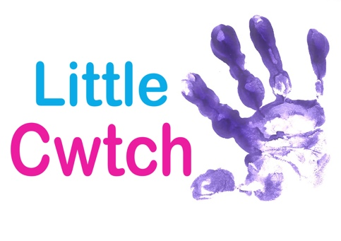
CHILD PROTECTION POLICY

THIS POLICY IS CURRENTLY UNDER CONTINUAL REVIEW to
Ensure compliance with the UK government review of the
Legislation

Overview .

Little Cwtch believes that the welfare of children and young people is paramount, and will act to ensure this to the best of their ability for all children and young people who participate as workshop/session attenders.

All children whatever their age, culture, disability, gender, language, racial origin, religious belief ect, have the right to protection from abuse.

As defined in the Children Act 1989, anyone under the age of 18 years should be considered as a child for the purpose of this document.

Definition .

‘The client’ shall be deemed to be the person or organization who has signed the agreement or contract to employ Little Cwtch to deliver a workshop

Education workshops and classes .

In all circumstances, the workshop/Class coordinator and/or the tutors will ensure that;

- The nature of the work is within the physical capabilities of the participants
- The Client/tutor is asked to ensure all participants are fit to take part before the session(s) start
- Participants parents/legal guardians are further asked to advise our tutors of any disabilities, injuries or illnesses, which may prevent/hinder them in taking part in all or some of the workshops/classes
- The Client/Tutor is asked to ensure and is responsible for ensuring the venue is a suitable space and fit for purpose
- The nature of the workshops/classes will be explained to the Client in advance by the coordinator/tutor, including awareness that dance tuition may necessarily involve some physical contact between participants themselves and participants and tutors
- There will always be a parent/guardian/teacher present in the younger “Little Cwtch Baby Sensory Classes”
- The Client must ensure that at least 1 adult teacher (or other appropriate adult) from the host organization is in attendance at all times and remains responsible for the participant’s welfare, behavior and personal needs and at no point should they consider ‘Little Cwtch” tutors can take over this responsibility
- Little Cwtch are within their rights to refuse to deliver a workshop/class if they believe the venue does not fulfil Health and Safety requirements

All Little Cwtch tutors will be asked to sign a code of conduct form and a copy of the procedures. All Little Cwtch tutors will be informed of the need to carry out a Disclosure and Barring Service check (formerly Criminal Records Bureau Check) prior to the beginning of a contract of employment unless the tutor is able to produce a certificate from the Disclosure and Barring Service undertaken within the last two years.

In the event of an accident or injury, the client is responsible for first aid administration, as the participant’s welfare remains the responsibility of the Client. However, Little Cwtch tutors will always carry a first aid kit and will report any incident in their accident/incident book as well as it being recorded in the Clients accident/incident book. All Little Cwtch tutors are fully first aid trained.

All tutors will be aware of Little Cwtch’s Health and Safety Policy.

Little Cwtch use film and still photography in their work and may use any material ‘shot’ during the workshop for promotional and documentary purposes. This is agreed in advance with the Client as part of the contractual process. The Client must notify Little Cwtch in writing if such material cannot be used, this is also part of the participant’s information sheets.

If Little Cwtch tutors are concerned in any way about any of the participants they should not act on their own, but refer to the responsible adult appointed by the Client.

All Little Cwtch tutors will refrain from using any language or behavior in front of the young people which could be deemed as offensive or sexual – Even in jest.

All Little Cwtch tutors will ensure that workshop content does not exceed the capabilities of the participants in question.

All Little Cwtch tutors will ensure that participants are not exposed to undue risk or cold or injury.

If Little Cwtch notice untoward behavior amongst participants, they will refer this to the responsible adult in attendance.

Little Cwtch tutors will not place unrealistic pressure or constant criticism to get the participant to perform to high expectations.

Internet Use .

Little Cwtch is aware that many of its social media engagers may be under 18 years of age and therefore ensures that staff are aware of Little Cwtch online relationship boundaries which are in line with the All Wales Child Protection Strategy (2008) and the guidelines set out by Childnet.

Contact Information
Contact Information:

Rowan Kennedy-Brown (Mobile) 07494433531

Billy Kennedy-Brown (Mobile) 07961626474

Version Control

Revised November 2019

